FOR IMMEDIATE RELEASE
October 8, 2026

WINNER OF EIGHT 2019 TONY AWARDS – INC. BEST MUSICAL
GRAMMY AWARD WINNER – BEST MUSICAL THEATER ALBUM

“SUMPTUOUS. GORGEOUS. AS GOOD AS IT GETS.”
— Jesse Green, The New York Times, NYT Critic's Pick

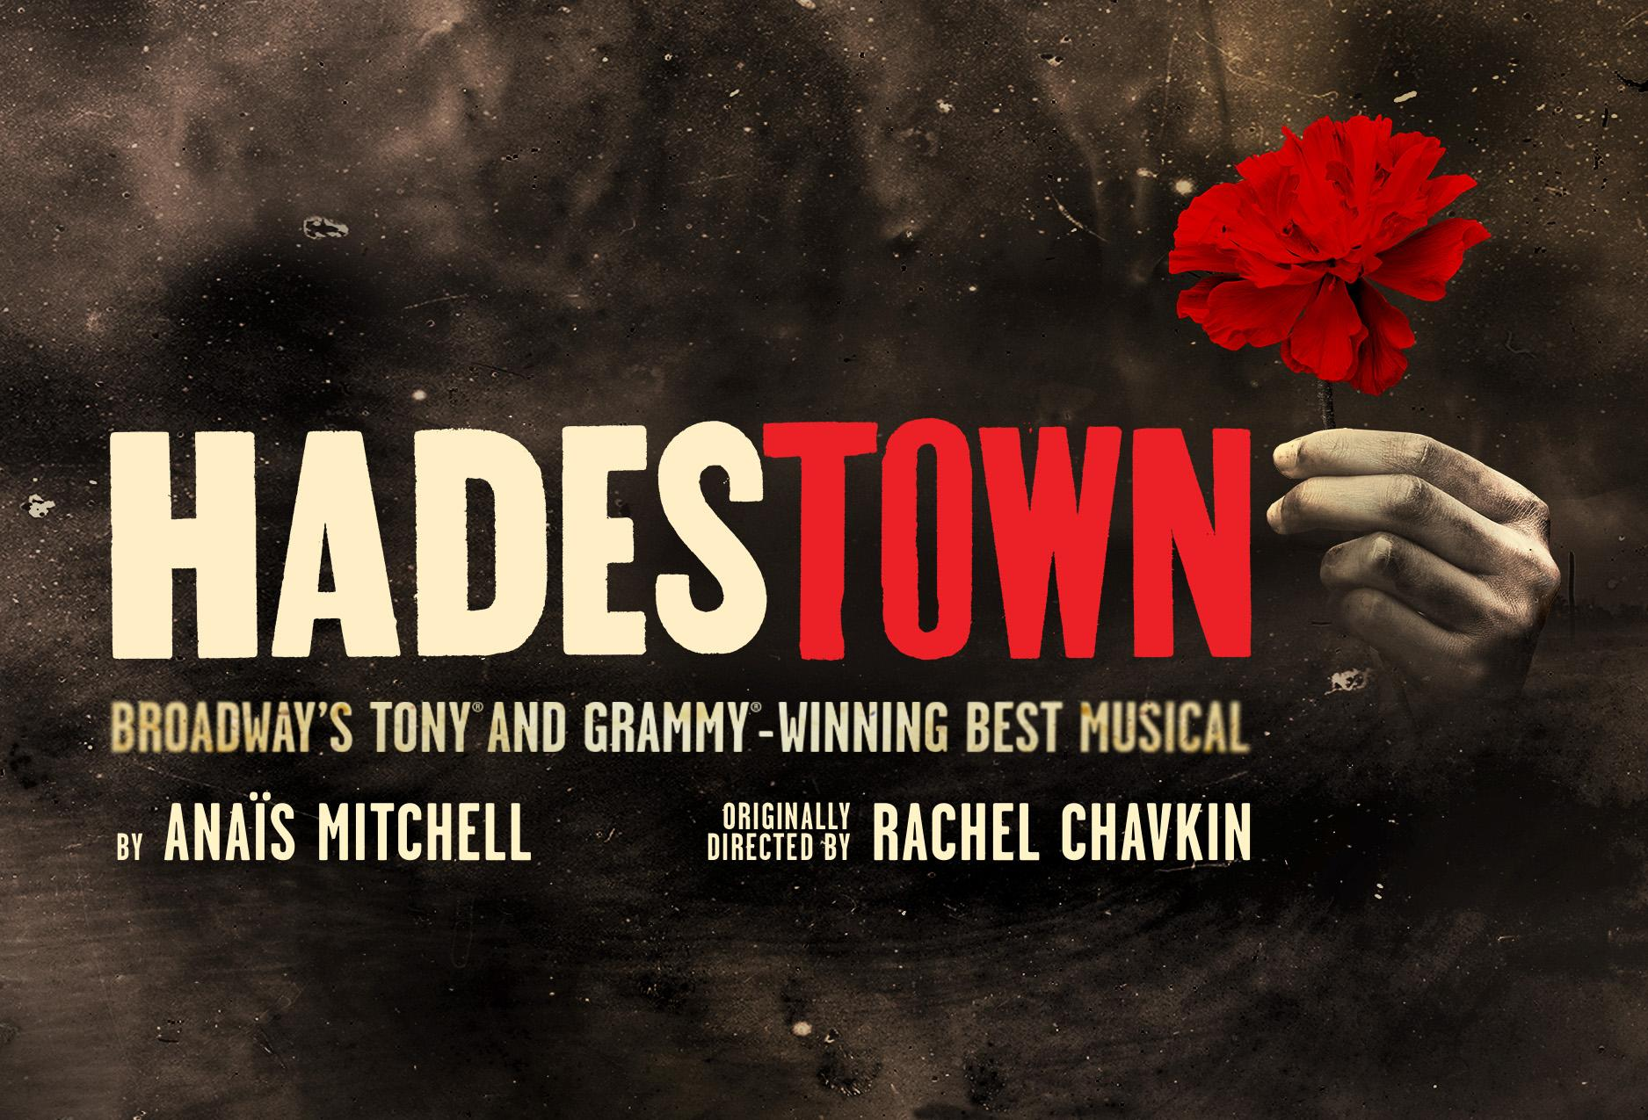

BROADWAY IN VICTORIA ANNOUNCES PREMIERE ENGAGEMENT OF HADESTOWN, JANUARY 12-17, 2027
AT THE ROYAL THEATRE

PUBLIC ON SALE, OCTOBER 16, 2026 — 10AM!

VICTORIA, BC — Come see how the world could be — HADESTOWN is coming to Victoria!

The producers of the North American tour of HADESTOWN, in partnership with Broadway in Victoria, announce that single tickets go on sale October 16, 2026 at 10AM PCT. Winner of eight 2019 Tony Awards, including Best Musical, and the 2020 Grammy Award for Best Musical Theater Album, HADESTOWN makes its eagerly awaited Victoria premiere January 12-17, 2027 at the Royal Theatre, 805 Broughton Street. Tickets are available at the Royal/McPherson Theatre box offices, online at RMTS.BC.CA or by calling 250-386-6121.

Welcome to HADESTOWN, where a song can change your fate. This acclaimed musical features music, lyrics, and book by celebrated singer-songwriter Anaïs Mitchell, developed with original director Rachel Chavkin (Natasha, Pierre & The Great Comet of 1812) and original choreography by David Neumann. The most awarded show of the 2018-2019 Broadway season, HADESTOWN is a timeless story told in an unforgettable way. In addition to its eight Tony Awards, HADESTOWN has been honored with four Drama Desk Awards, six Outer Critics Circle Awards, including Outstanding New Broadway Musical, and the Drama League Award for Outstanding Production of a Musical. HADESTOWN also marks the first time in over a decade that a woman has been the solo author of a musical, and only the fourth time in Broadway history a woman has accomplished this creative feat.

HADESTOWN intertwines two mythic love stories—including young dreamers Orpheus and Eurydice and King Hades and his wife Persephone—inviting audiences on a hell-raising journey to the underworld and back. Mitchell's beguiling melodies and Chavkin's poetic imagination pit industry against nature, doubt against faith, and fear against love. Blending modern American folk music with New Orleans-inspired jazz, and performed by a vibrant ensemble of actors, dancers, and singers, HADESTOWN delivers a haunting, hopeful theatrical experience that grabs you and never lets go.

The North American tour of HADESTOWN brings the show's inventive staging and Tony-winning design to audiences across the continent, under the direction of Keenan Tyler Oliphant and choreography by T. Oliver Reid. The cast features: Nickolaus Colón as Hades, Jose Contreras as Orpheus, Rudy Foster as Hermes, Hawa Kamara as Eurydice, Namisa Mdlalose Bizana as Persephone, and Gia Keddy, Miriam Navarrete, and Jayna Wescoatt as the three Fates.

The ensemble includes: Travis Darghali, Lilli Doll, Vanessa Dominguez, Tyler Ray Lewis, Jadon Lopez, Mya Lynae, Ben Raanan, Julia Schick, and Ty Shay.

The tour’s creative team includes: Cody Owen Stine (Music Supervisor), Arman Wali Mohammad (Music Director), Keith Levenson (Music Contractor) Lauryn Elizabeth (Production Stage Manager), Audrey Michael (Assistant Stage Manager), Molly Goodwin (Consulting Stage Manager), Ellie Howell (Company Manager), Alec Richards (Assistant Company Manager), and Mark Lunsford (Creative Producer).

Additional creative team credits include: David L. Arsenault (Scenic Design), Michael Krass (Costume Design), Aja Jackson (Lighting Design), Nevin Steinberg/Jessica Paz (Co-Sound Design), Liam Robinson (Vocal Arrangements & Music Consultant), Michael Chorney/Todd Sickafoose (Arrangements & Orchestration), and Jennifer Mullins (Hair & Wig Design).

Casting is by Whitley Theatrical, Production Management by Sightline Productions, General Management by RCI Theatricals - Kevin Greene, Tour Booking by The Booking Group, and Tour Marketing & Press by Allied Global Marketing.

HADESTOWN was co-conceived by Ben t. Matchstick. The show originated as Mitchell's indie theatre project touring Vermont, which she then turned into an acclaimed concept album, before electrifying audiences with its 2016 world premiere at New York Theatre Workshop, the longest-running show in that celebrated theatre's 40-year history. The production went on to a 2017 Canadian premiere at Edmonton's Citadel Theatre and a sold-out 2018 engagement at London's National Theatre, before opening on Broadway at the Walter Kerr Theatre on April 17, 2019, where it continues to play today.

For more information, visit hadestownontour.com

About Broadway in Victoria (broadwayinvictoria.com)
Broadway in Victoria's mission is to provide Vancouver Island residents with an opportunity to experience world class musical theatre in their home city. Every year its audience members can expect a magical Broadway experience in the intimacy of the beautifully restored Royal Theatre. Over the past decade, it has hosted acclaimed touring productions of MAMMA MIA!, CHICAGO, BEAUTIFUL: The Carole King Musical, COME FROM AWAY, JESUS CHRIST SUPERSTAR, THE BOOK OF MORMON, and TINA – The Tina Turner Musical, SPAMALOT, among others. The company is driven by a strong belief that Victoria is among Canada's cultural capitals and is dedicated to enhancing the city's vibrant arts and culture community.

LISTING INFORMATION Broadway in Victoria presents HADESTOWN

Dates: January 12-17, 2027

Address: Royal Theatre
805 Broughton St, Victoria

Box Office: rmts.bc.ca

Website: broadwayinvictoria.com

-30-

For further media information, contact
Brian Paterson | 778.319.4165 | bpaterson@mpmgarts.com



