FOR IMMEDIATE RELEASE
May 15, 2026

THREE-TIME TONY AWARD WINNER – INC. BEST MUSICAL
THREE-TIME DRAMA DESK AWARD WINNER – INC. OUTSTANDING MUSICAL
GRAMMY AWARD WINNER – BEST MUSICAL THEATER ALBUM

“A HILARIOUS FUNFEST filled with true Broadway RAZZLE DAZZLE!”
– Entertainment Weekly

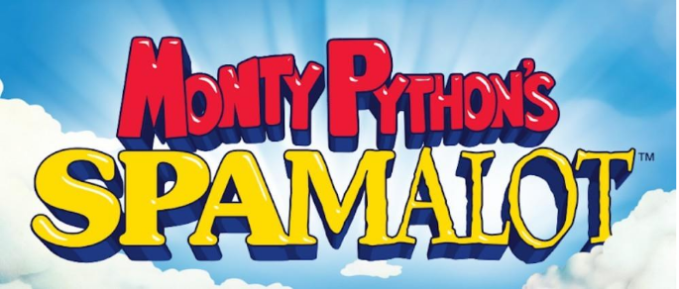

BROADWAY IN VICTORIA ANNOUNCES PREMIERE ENGAGEMENT OF MONTY PYTHON’S SPAMALOT, AUGUST 28-30, 2026
AT THE ROYAL THEATRE

PUBLIC ON SALE MAY 22, 2026 – 10AM!

VICTORIA, BC — The quest for the Holy Grail begins in Victoria!

The producers of the North American tour of MONTY PYTHON’S SPAMALOT, in partnership with Broadway in Victoria, announce that single tickets go on sale May 22, 2026 at 10AM PDT. Hot off a critically acclaimed Broadway revival in 2023, SPAMALOT makes its eagerly awaited Victoria premiere on August 28-30, 2026 at the Royal Theatre, 805 Broughton Street. Tickets are available at the Royal/McPherson Theatre box offices, online at RMTS.BC.CA or by calling 250-386-6121.

Victoria audiences are invited to gallop into the theatre to enjoy a raucously entertaining ‘knight’ with SPAMALOT–the multiple award-winning musical including three Tony Awards and a Grammy Award for Best Musical Theater Album. Lovingly pilfered from the classic film, Monty Python and the Holy Grail, and filled with its distinctly British wit and comedic brilliance, SPAMALOT features a book & lyrics by Eric Idle, and music by John Du Prez and Eric Idle.

From flying cows to killer rabbits, British royalty to French taunters, dancing girls, rubbery shrubbery, and of course, the Lady of the Lake, SPAMALOT features a collection of hilariously satirical songs, including “Always Look on the Bright Side of Life,” “The Song That Goes Like This,” “Brave Sir Robin” and more that have become beloved classics in the musical theatre canon.

Fresh off a 2023 Broadway revival at the St. James Theatre, MONTY PYTHON’S SPAMALOT will bring its inventive staging, design, and exceptional performances on an all-new North American tour, under the direction and choreography of Josh Rhodes. The cast features: Major Attaway as King Arthur, Sean Bell as Sir Robin, Chris Collins-Pisano as Sir Lancelot, Ellis C. Dawson III as Sir Bedevere, Leo Roberts as Sir Galahad, Amanda Robles as The Lady of the Lake, Blake Segal as Patsy, and Steven Telsey as The Historian/Prince Herbert.

The ensemble includes: Lindsay Lee Alhady, Delaney Benson, Jack Brewer, Connor Coughlin, L’ogan J’ones, Graham Keen, Claire Kennard, Ben Lanham, Nathaniel Mahone, Maddie Mossner, Emilie Renier, Mark Tran Russ, and Meridien Terrell.

The tour’s creative team includes Derek Kolluri (Associate Director), Michael Fatica (Associate Choreographer), John Bell (Music Supervision), Jonathan Gorst (Music Director/Conductor), Matthew Brooks (Production Stage Manager), Anna K. Rains (Stage Manager), Dani Berman (Assistant Stage Manager), James Neal (Company Manager), Kat McIntyre (Assistant Company Manager), and Geoff Josselson (Casting). SPAMALOT is produced by Jeffrey Finn, and RCI Theatricals serves as General Manager.

Additional creative team credits include Paul Tate dePoo III (Scenic and Projection Design), Jen Caprio (Costume Design), Cory Pattak (Lighting Design), Kai Harada & Haley Parcher (Sound Design), and Tom Watson (Wig Design).
For more information, visit spamalotthemusical.com

About Broadway in Victoria (broadwayinvictoria.com)
Broadway in Victoria’s mission is to provide Vancouver Island residents with an opportunity to experience world class musical theatre in their home city. Every year its audience members can expect a magical Broadway experience in the intimacy of the beautifully restored Royal Theatre. Over the past decade, it has hosted acclaimed touring productions of MAMMA MIA!, CHICAGO, BEAUTIFUL: The Carole King Musical, COME FROM AWAY, JESUS CHRIST SUPERSTAR, THE BOOK OF MORMON, and TINA – The Tina Turner Musical, among others. The company is driven by a strong belief that Victoria is among Canada’s cultural capitals and is dedicated to enhancing the city’s vibrant arts and culture community.

LISTING INFORMATION Broadway in Victoria presents SPAMALOT

Dates: August 28-30, 2026
Address: Royal Theatre
805 Broughton St, Victoria

Box Office: rmts.bc.ca
Website: broadwayinvictoria.com

-30-

For further media information, contact
Brian Paterson | 778.319.4165 | bpaterson@mpmgarts.com



