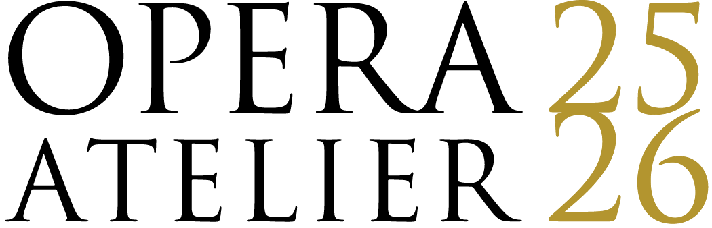

FOR IMMEDIATE RELEASE

February 4,2025

**Opera Atelier Celebrates 40 Years with a Season of Magic**

***The 2025/26 season launches with the iconic production of Mozart’s***

***The Magic Flute and continues with the Canadian premiere of a new production of Debussy’s surrealist opera, Pelléas et Mélisande***

**Toronto, ON** — Opera Atelier celebrates its landmark 40th year with two significant productions:

the company’s iconic production of **Mozart’s *The Magic Flute,* on stageOctober 15, 16, 18 and 19, 2025** at the **Elgin Theatre**, and the world premiere of **Debussy’s surrealist opera, *Pelléas et Mélisande,* on stage April 15, 16, 18 and 19 2026** at **Koerner Hall TELUS Centre for Performance and Learning.**

“We’re thrilled to open our season in Toronto’s historic Elgin Theatre with the company’s period production of Mozart’s *The Magic Flute,* part of our 40th anniversary celebrations,*”* says Opera Atelier Founding Co-artistic Director Marshall Pynkoski. “Opera Atelier’s *Magic Flute* remains North America’s first and only period production of the Opera and has proven to be a cherished piece of music theatre that appeals to children, adults, first-time opera goers and opera aficionados alike.”

Sung in Andrew Porter’s delightful English translation, Opera Atelier’s production pays tribute to Mozart’s intention to create an accessible comic masterpiece. Magically redesigned in 2013 by Gerard Gauci, the production features dragons, flying machines, and 18th century special effects that heighten the opera’s fairy tale atmosphere as we follow Prince Tamino and the bird-man Papageno on their journey to free the princess Pamina from the Queen of the Night.

*The Magic Flute* will feature many of the company’s audience favourite singers, including tenor Colin Ainsworth as Tamino, soprano Meghan Lindsay, who makes her role debut as Pamina and bass baritone Douglas Williams making his role debut as Papageno. The impressive cast also includes bass-baritone Stephen Hegedus as Sarastro, tenor Blaise Rantoanina as Monastatos, and soprano Karine White as Papagena. The Three Ladies are sung by soprano Carla Huhtanen, mezzo-soprano Danielle MacMillan, and mezzo-soprano Laura Pudwell. Opera Atelier is particularly delighted to welcome soprano Rainelle Krause, who is making her much anticipated Opera Atelier debut as Queen of the Night - a role that has won her international acclaim.

Opera Atelier’s production of *The Magic Flute* includes Opera Atelier Music Director David Fallis conducting Tafelmusik Baroque Orchestra, the full corps of the Artists of Atelier Ballet, and the Nathaniel Dett Chorale making their onstage debut with Opera Atelier. *The Magic Flute* will be directed by Opera Atelier Founding Co-artistic Director Pynkoski and choreographed by Jeannette Lajeunesse Zingg, with set design by Gerard Gauci, costume design by Dora Rust-d’Eye, and lighting design by Kimberly Purtell.

The season continues in the spring with the Toronto premiere of Opera Atelier’s distinctive version of Debussy’s dream-like masterpiece, *Pelléas et Mélisande*. The production will take place fully staged in Koerner Hall TELUS Centre for Performance and Learning, which will be transformed into a unique performance space with major architectural additions thanks to the Jerry and Joan Lozinski Opera Atelier Reimagined Project at Koerner Hall.

The groundbreaking production of *Pelléas et Mélisande* takes Opera Atelier and Tafelmusik Baroque Orchestra into the latest repertoire either company has ever produced, creating a whole new definition for period production.

"Debussy's surrealist masterpiece lifts us out of the parameters of life as we know it and projects us into a world in which dreams collide with reality,” says Pynkoski. “While preparing to direct this production of *Pelléas*, I keep in mind the statement by the great late film director David Lynch: 'I like to leave some room to dream. A lot of mysteries are sewn up at the end. That kills the dream.'"

Debussy’s *Pelléas et Mélisande* is based on the symbolist play by Maurice Maeterlinck, in which a prince, lost in a forest, discovers a beautiful woman weeping beside a pool of water - bringing him in contact with a supernatural world from which there is no escape.

The extraordinary cast features tenor Antonin Rondepierre as Pelléas, soprano Meghan Lindsay as Mélisande, bass-baritone Douglas Williams as Golaud, bass-baritone Philippe Sly making his Opera Atelier debut as Arkel, soprano and Opera Atelier Artist-in-Residence soprano Measha Brueggergosman-Lee as Geneviève, and Mezzo-Soprano Cynthia Akemi-Smithers as ​​Yniold.

"Debussy's deep admiration for 17th century French music runs like an undercurrent throughout *Pelléas et Mélisande,* making his mysterious, magical composition particularly suited to my sensibilities as a choreographer of Baroque dancing and classical ballet,” says Lajeunesse Zingg. “In OA's production of *Pelléas et Mélisande*, the Artists of Atelier Ballet represent invisible forces of nature that drive the actions of the characters on stage."

Opera Atelier’s production of *Pelléas et Mélisande* will feature David Fallis conducting Tafelmusik Baroque Orchestra, and the full corps of the Artists of Atelier Ballet. *Pelléas et Mélisande* will be directed by Pynkoski and choreographed by Lajeunesse Zingg, with set design by Gauci, costume design by Michael Gianfrancesco, and lighting design by Purtell.

**2025/26 Season Subscriptions will go on sale on February 4, 2025.** Subscriptions can be purchased at **OperaAtelier.com** or by calling 416-703-3767 x 700.

Single Tickets for *The Magic Flute* will be on sale September 3, 2025.

Single Tickets for *Pelléas et Mélisande* will be on sale February 18, 2026.

*Opera Atelier gratefully acknowledges the ongoing support of The Canada Council for the Arts, the Ontario Arts Council, and the City of Toronto through the Toronto Arts Council.*

**To download the 2025/26 season press kit, click** [**HERE**](https://mpmgarts.com/media/campaigns/opera-atelier-2025-2026-season-announcement)**.**

**About Opera Atelier (OperaAtelier.com)**

Opera Atelier is North America’s leading opera/ballet company dedicated to creating period productions realized as complete artistic statements - with equal attention given to music, dancing, acting, and design. With productions performed in partnership with award-winning period-instrument orchestra, Tafelmusik, Opera Atelier has toured to major opera houses and festivals internationally. Opera Atelier is dedicated to equity, diversity and inclusion, the education of youth and young artists, and offers a robust slate of education, enrichment and outreach opportunities to engage audience members of all ages.Since 1985, Opera Atelier has been led by co-founding Artistic Directors Marshall Pynkoski and Jeannette Lajeunesse Zingg, who most recently, were both named members of the Order of Canada and Officers of the Order of Arts and Letters (Officiers dans l’Ordre des Arts et des Lettres) by the French Republic.

-30-

___________________________________________________________________________

**For further media information, contact:**

Laura Murray | 604.418.2998 | lmurray@mpmgarts.com

Angela Poon | 604.569.5343| [apoon@mpmgarts.com](mailto:apoon@mpmgarts.com)

